CSC223 Data Comm. 12th MAY ‘22

Question Four

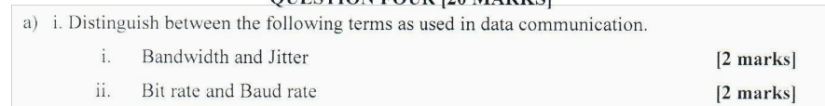  
i. \*\*Bandwidth and Jitter:\*\*

- \*\*Bandwidth:\*\* It refers to the maximum data transfer rate of a communication channel. It is the amount of data that can be transmitted in a fixed amount of time. Bandwidth is typically measured in bits per second (bps) or its multiples (kbps, Mbps, etc.).

- \*\*Jitter:\*\* Jitter is the variability in the arrival time of data packets. It is a measure of the deviation from the regular, predictable timing of the data transfer. In other words, it reflects the irregularities in the timing of signal arrivals.

ii. \*\*Bit rate and Baud rate:\*\*

- \*\*Bit rate:\*\* Bit rate is the number of bits transmitted per unit of time. It measures the speed of data transmission in a communication channel and is usually expressed in bits per second (bps).

- \*\*Baud rate:\*\* Baud rate, on the other hand, is the number of signal changes (voltage or frequency) per second in a communication channel. It represents the number of symbols transmitted per second and is not necessarily equal to the bit rate. Baud rate is measured in baud. In some cases, bit rate and baud rate can be the same, but they can differ in certain modulation schemes.

In summary:

- Bandwidth is about the capacity of the channel in terms of data transfer.

- Jitter is about the variation in the timing of signal arrivals.

- Bit rate is about the number of bits transmitted per unit of time.

- Baud rate is about the number of signal changes per second, representing the number of symbols transmitted.

  
The OSI (Open Systems Interconnection) model consists of seven layers, each serving a specific purpose in facilitating communication between computer systems. Here is a concise overview of each layer:

1. \*\*Physical Layer (Layer 1):\*\*

- Function: Deals with the physical connection between devices.

- Responsibilities: Defines hardware aspects such as cables, connectors, and transmission rates.

2. \*\*Data Link Layer (Layer 2):\*\*

- Function: Responsible for node-to-node communication and error detection on the physical layer.

- Responsibilities: Frames data for transmission, handles error detection, and manages access to the physical medium.

3. \*\*Network Layer (Layer 3):\*\*

- Function: Manages end-to-end communication and routing between devices across different networks.

- Responsibilities: Addresses, routes, and forwards data packets between devices in different networks.

4. \*\*Transport Layer (Layer 4):\*\*

- Function: Ensures end-to-end communication, reliability, and flow control.

- Responsibilities: Segments and reassembles data, handles error recovery, and controls data flow.

5. \*\*Session Layer (Layer 5):\*\*

- Function: Manages sessions or connections between applications on different devices.

- Responsibilities: Establishes, maintains, and terminates sessions, and manages dialog control.

6. \*\*Presentation Layer (Layer 6):\*\*

- Function: Focuses on the format and syntax of data exchanged between applications.

- Responsibilities: Translates, encrypts, or compresses data as needed, ensuring compatibility between different systems.

7. \*\*Application Layer (Layer 7):\*\*

- Function: Provides a user interface and network services for applications.

- Responsibilities: Enables communication between software applications and network services, handling tasks such as file transfers, email, and remote file access.

In summary, the OSI model organizes the functions of a communication system into distinct layers, allowing for modular design, easier troubleshooting, and interoperability between different systems and technologies.

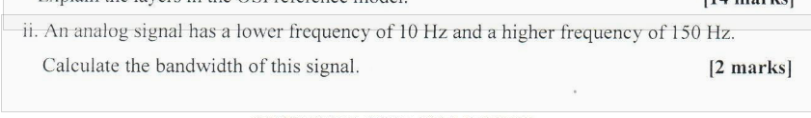

Bandwidth is the difference between the highest and lowest frequencies in a signal.

For the given analog signal:

Lower frequency = 10 Hz

Higher frequency = 150 Hz

Bandwidth = Higher frequency - Lower frequency

Bandwidth = 150 Hz - 10 Hz

Bandwidth = 140 Hz

Question Five  
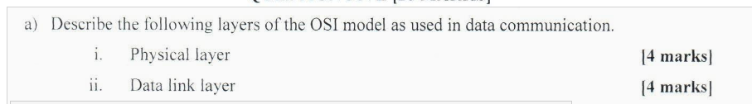

i. \*\*Physical Layer:\*\*

The Physical Layer, the first layer of the OSI model, deals with the physical connection between devices. It's responsible for transmitting raw data bits over a communication channel. Key functions include encoding, modulation, and transmission of signals over the medium. It defines characteristics such as voltage levels, cable types, and data rates. Examples of components at this layer include cables, connectors, hubs, and repeaters.

ii. \*\*Data Link Layer:\*\*

The Data Link Layer is responsible for the reliable transmission of data frames between adjacent nodes connected by a physical layer. It provides error detection and correction, as well as framing, addressing, and flow control mechanisms. This layer ensures data integrity and establishes a point-to-point or point-to-multipoint connection. Examples of devices operating at this layer are switches and network interface cards (NICs).



Advantages of message switching technique:

1. \*\*Robustness\*\*: Message switching is resilient to network failures as it allows messages to be rerouted dynamically, ensuring communication continuity even if some nodes fail.

2. \*\*Efficiency\*\*: It optimizes network resources by transmitting messages independently, allowing for better utilization of available bandwidth and reducing the risk of bottlenecks.

3. \*\*Scalability\*\*: Message switching scales well with network size since it doesn't require establishing a dedicated end-to-end connection for each communication, making it suitable for large-scale systems.

4. \*\*Flexibility\*\*: It supports various types of data formats and protocols, enabling heterogeneous devices and systems to communicate effectively without strict compatibility requirements.

5. \*\*Adaptability\*\*: Message switching can adapt to varying network conditions, adjusting message routing and prioritization based on real-time factors like congestion levels or node availability.

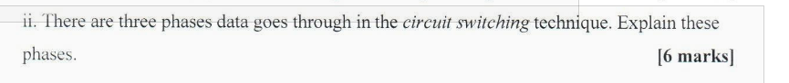

In circuit switching, data transmission involves three main phases:

1. \*\*Establishment Phase\*\*:

- During this phase, a dedicated communication path, or circuit, is set up between the sender and the receiver.

- Resources such as bandwidth and network capacity are allocated for the duration of the communication session.

- This phase involves signaling and negotiation between the sender and the receiver to establish the connection.

2. \*\*Data Transfer Phase\*\*:

- Once the circuit is established, data transmission occurs over the dedicated path.

- Data is sent in a continuous stream without the need for addressing information since the circuit is already established.

- The sender and receiver nodes communicate directly without involving intermediate network nodes.

3. \*\*Release Phase\*\*:

- After the data transfer is complete or the communication session ends, the circuit is torn down, and resources are released.

- The resources allocated for the connection are freed up for future use.

- This phase involves signaling to terminate the connection and release the dedicated resources.

These phases ensure efficient utilization of resources for communication while providing a continuous and dedicated connection between the communicating parties.

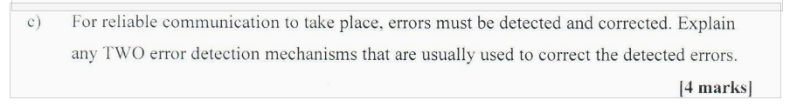

Two common error detection mechanisms used for correcting detected errors in reliable communication are:

1. \*\*Checksums\*\*: Checksums involve adding a check value to the data being transmitted. This check value is computed based on the contents of the data. At the receiving end, the check value is recalculated, and if it does not match the transmitted check value, an error is detected. Checksums are commonly used in network protocols like TCP/IP to ensure data integrity.

2. \*\*Parity Checking\*\*: Parity checking involves adding an additional bit (parity bit) to each unit of data being transmitted. The parity bit is set so that the total number of bits set to 1 is either even (even parity) or odd (odd parity). At the receiving end, the parity of the received data is checked. If it does not match the expected parity, an error is detected. Parity checking is often used in memory systems and serial communication.